**Title of assignment: Divide and Conquer Strategy**

Name: Mayur Savale

PRN:21520010

**Strassen’s Matrix Multiplication**

1. Implement Naive Method multiply tow matrices and justify Complexity is O(n3).

Ans:

1. **Algorithm: (Pseudocode)**

* We know that value of any element in resultant matrix is the sum of the product of the ith row of first matrix and the jth column of second matrix.
* So we traverse the matrix in to for loop and then apply third loop in the two for loop for sum of the products of the row and column.

1. **Code snapshots of implementation**

#include<bits/stdc++.h>

using namespace std;

int main()

{

int n;

cout<<"Enter size of square matrix: ";

cin>>n;

int a[n][n];

int b[n][n];

cout<<"Enter elements of matrix A:\n";

for(int i=0;i<n;i++)

{

for(int j=0;j<n;j++)

cin>>a[i][j];

}

cout<<"Enter elements of matrix B:\n";

for(int i=0;i<n;i++)

{

for(int j=0;j<n;j++)

cin>>b[i][j];

}

cout<<"Matrix Multiplication is\n";

int c[n][n];

for(int i=0;i<n;i++)

{

for(int j=0;j<n;j++)

{

c[i][j]=0;

for(int k=0;k<n;k++)

c[i][j]+=a[i][k]*b[k][j];

}

}

for(int i=0;i<n;i++)

{

for(int j=0;j<n;j++)

cout<<c[i][j]<<"\t";

cout<<"\n";

}

return 0;

}

**Output:**

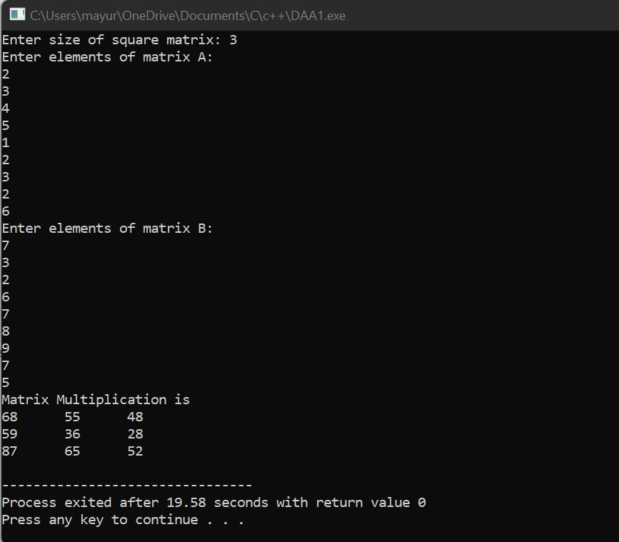

1. **Complexity of proposed algorithm (Time & Space)**

* Time Complexity: O(n3)

For accessing all the elements of any matrix we need two for loops. But to find the product we require on additional for loop

* Space Complexity: O(n2)

1. Implement Divide and Conquer multiply two matrices and justify Complexity is O(n3)

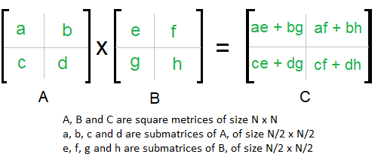

Ans:

1. **Algorithm: (Pseudocode)**

* Divide matrices A and B in 4 sub-matrices of size N/2 x N/2 as shown in figure
* Calculate the values recursively ae+bg,af+bh,ce+dg,cf+dh

1. **Code snapshots of implementation**

#include<bits/stdc++.h>

using namespace std;

const int MAX=100;

void multiplyMatrixRec(int r1,int c1,int a[][MAX],int r2,int c2,int b[][MAX],int c[][MAX])

{

static int i=0,j=0,k=0;

if(i>=r1)

return;

if(j<c2)

{

if(k<c1)

{

c[i][j]+=a[i][k]*b[k][j];

k++;

multiplyMatrixRec(r1,c1,a,r2,c2,b,c);

}

k=0;

j++;

multiplyMatrixRec(r1,c1,a,r2,c2,b,c);

}

j=0;

i++;

multiplyMatrixRec(r1,c1,a,r2,c2,b,c);

}

void multiplyMatrix(int r1,int c1,int a[][MAX],int r2,int c2,int b[][MAX])

{

if(r2!=c1)

{

cout<<"Not Possible\n";

return;

}

int c[MAX][MAX]={0};

multiplyMatrixRec(r1,c1,a,r2,c2,b,c);

for(int i=0;i<r1;i++)

{

for(int j=0;j<c2;j++)

cout<<c[i][j]<<"\t";

cout<<"\n";

}

}

int main()

{

int a[][MAX]={{1,2,3},{4,5,6},{7,8,9}};

int b[][MAX]={{1,2,3},{4,5,6},{7,8,9}};

cout<<"Matrix Multiplication is\n";

multiplyMatrix(3,3,a,3,3,b);

return 0;

}

**Output:**

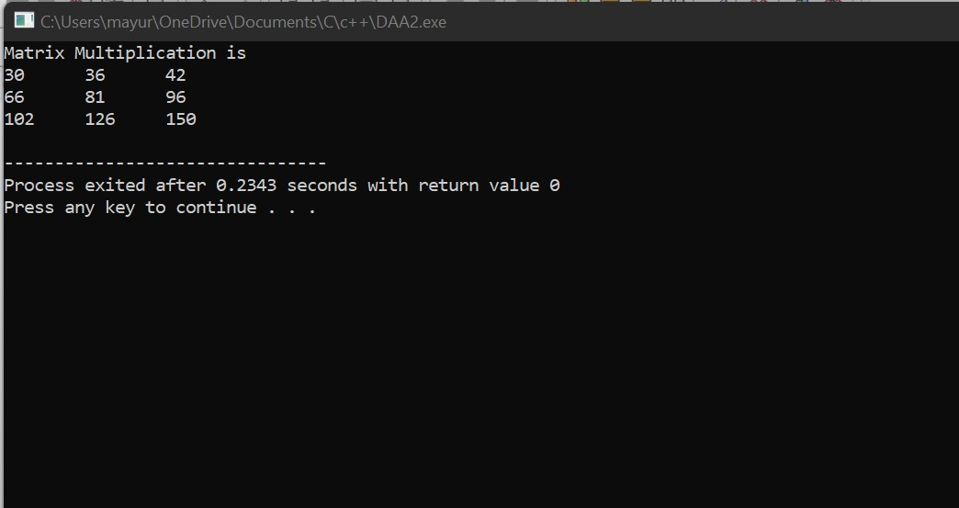

1. **Complexity of proposed algorithm (Time & Space)**

* Time Complexity: O(n3)

To solve this problem using D & C for the given problem we are doing * multiplications for matrices of size N/2 x N/2 and 4 additions

Addition of two matrices take (n2) time.

So we can write the complexity as

T(n) = 8*T(N/2) + O(n2)

1. Implement Strassen’s Matrix Multiplication and justify Complexity is O(n2.8)

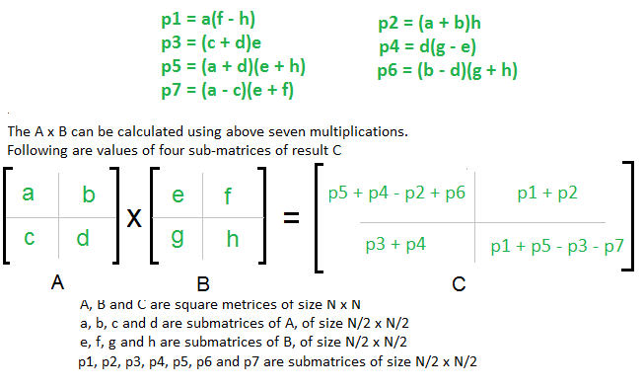

Ans:

1. **Algorithm: (Pseudocode)**

* It is similar as divide and conquer method only difference is that the fore submatrices of the result are calculated using the above formula

1. **Code snapshots of implementation**

#include<bits/stdc++.h>

using namespace std;

int main()

{

int a[2][2],b[2][2],c[2][2],i,j;

int m1,m2,m3,m4,m5,m6,m7;

cout<<"Enter the elements of first matrix:\n";

for(i=0;i<2;i++)

{

for(j=0;j<2;j++)

cin>>a[i][j];

}

cout<<"Enter the elements of second matrix:\n";

for(i=0;i<2;i++)

{

for(j=0;j<2;j++)

cin>>b[i][j];

}

m1=(a[0][0]+a[1][1])*(b[0][0]+b[1][1]);

m2=(a[1][0]+a[1][1])*b[0][0];

m3=a[0][0]*(b[0][1]-b[1][1]);

m4=a[1][1]*(b[1][0]-b[0][0]);

m5=(a[0][0]+a[0][1])*b[1][1];

m6=(a[1][0]-a[0][0])*(b[0][0]+b[0][1]);

m7=(a[0][1]-a[1][1])*(b[1][0]+b[1][1]);

c[0][0]=m1+m4-m5+m7;

c[0][1]=m3+m5;

c[1][0]=m2+m4;

c[1][1]=m1-m2+m3+m6;

cout<<"After multiplication of matrices:\n";

for(i=0;i<2;i++)

{

for(j=0;j<2;j++)

cout<<c[i][j]<<"\t";

cout<<"\n";

}

}

**Output:**

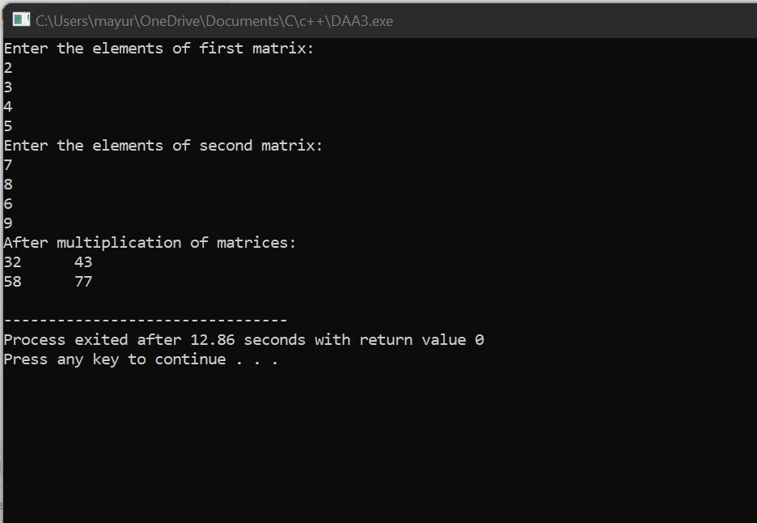

1. **Complexity of proposed algorithm (Time & Space)**

* Time Complexity:

Addition and Subtraction of two matrices take O(N2) time.

So time complexity can be written as

T(N) = 7T(N/2) + O(N2)

From Master’s Theorem, time complexity of above methos is O(Nlog7) which is approximately O(N2.8074)

Generally, Strassen’s Method is not preferred for practical application for the following reasons.

1. The constants used is Strassen’s method are high and for a typical application Naïve method works better.
2. For Spares matrices, there are better methods especially designed for them.